Town of Woodsboro, Texas
“The Friendly City”
Utility Payment VIA ACH (Debit)

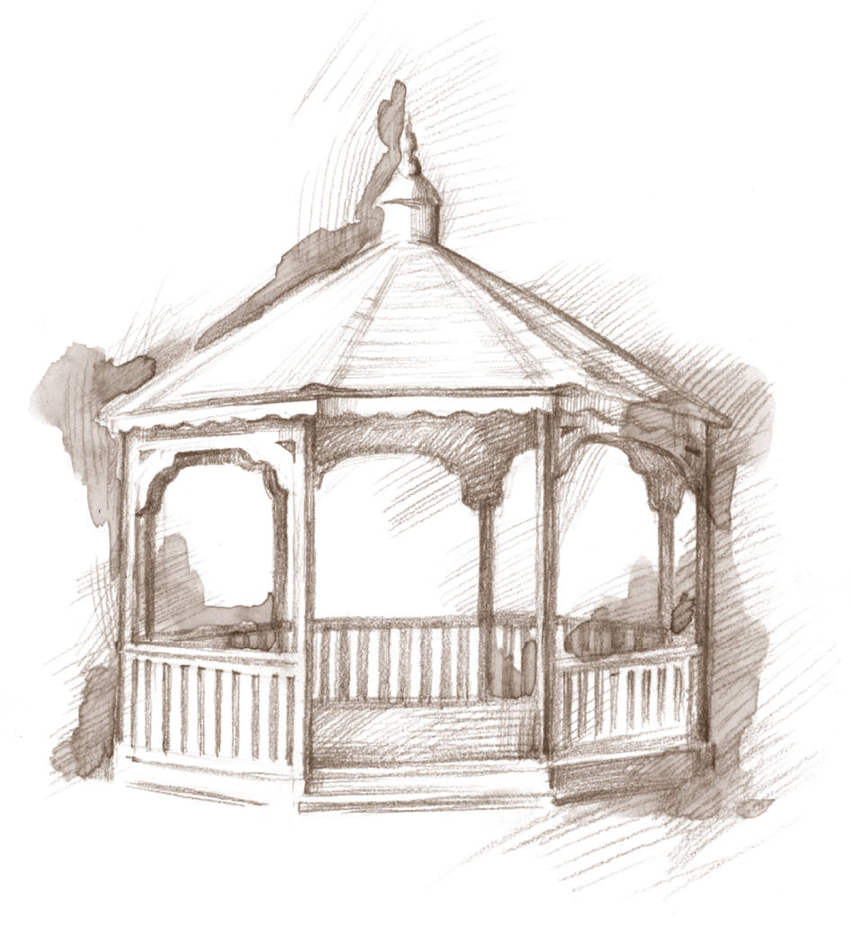

I (we) hereby authorize the Town of Woodsboro (“COMPANY”) to initiate debit entries to transfer funds from my (our)
Checking Account Savings Account (select one) indicated below at the depository financial institution named below (“DEPOSITORY”). I (we) agree that the ACH transactions authorized herein shall comply with the applicable law.

______________________________________________ __________________________________________
Depository Bank Name/Branch Office Address

_________________________________________ ________________________ ____________________
City State Zip Code

Depository’s Transit Routing Number

Account Number

______________________________________________ __________________________________________
Name(s) on Account Address

_________________________________________ ________________________ ____________________
City State Zip Code

Amount of debit(s) or method of determining amount of debits(s) [or specify range of acceptable dollar amounts authorized]:

This authorization shall remain in full force and effect until Company has received notification from me (or either of us) of its termination. A written statement requesting termination of automatic debit must be received 15 business days prior to debit being processed.

_______________________________________________ _______________________________
Signature Date

_______________________________________________ _______________________________
Signature Date

