Town of Woodsboro, Texas
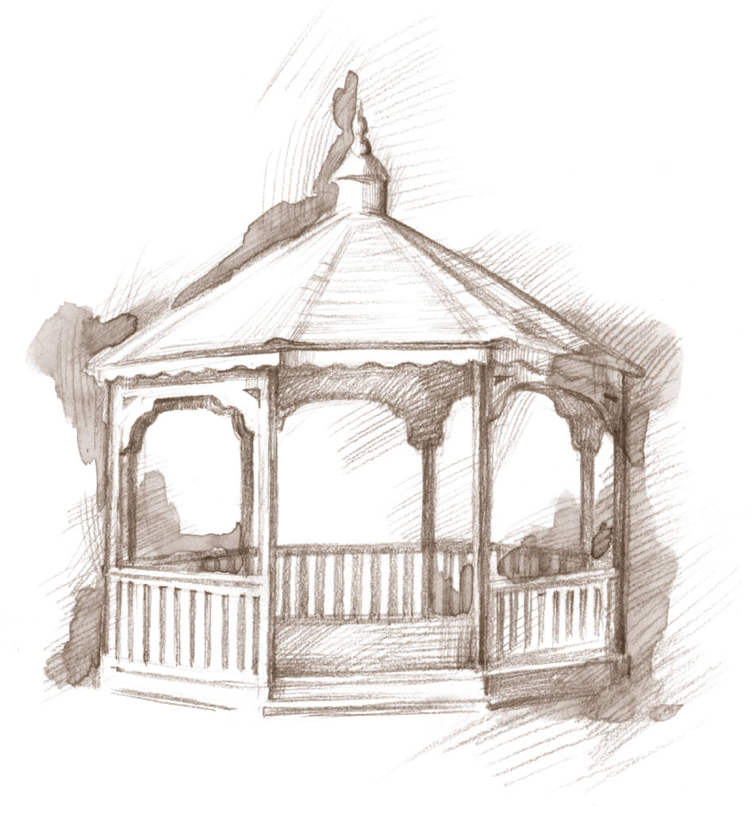
Telephone: (361)543-4505
P O Box 632 110 Wood Ave.

Application for Building Permit
Includes Manufactured and Mobile Homes

Owner Name:___________________________________________ Date: ________________

Physical Address (frontage on street) ______________________________________________________________

Lot # __________________ Block # ________________ Subdivision ___________________

Mailing Address:______________________________________________________________

Phone & Email:_______________________________________________________________

Plans / Building documentation submitted with application

Contractor Name: ____________________________________________________________

Contractor Address: __________________________________________________________

Estimated completion date:_____________________________________________________

Square Footage of Building: _____________________

Permit Fee
Residential: ____________ X $0.30 = ___________________
square foot of building permit fee

Commercial: ____________ X $0.50 = ___________________
square foot of building permit fee

_____________________________ _______________________________
Customer Signature Clerk Signature

Office Use Only

Permit # _______________________

