

**Town of Woodsboro, Texas**

***“The Friendly City”***

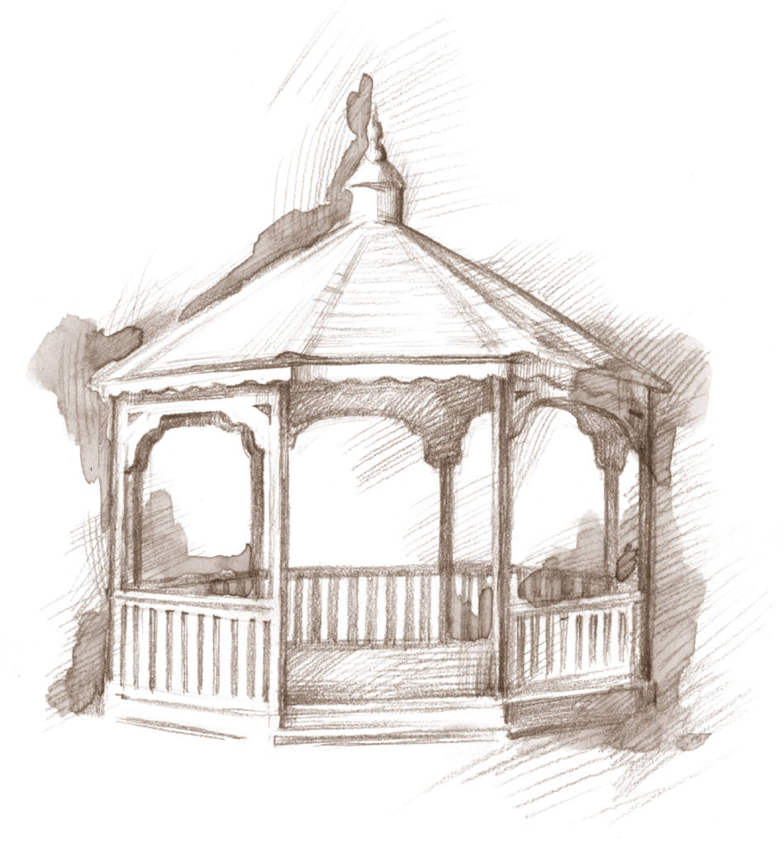

**Viola Meza**

Water Clerk

waterclerk@woodsborotx.net

P.O. Box 632

113 Wood Avenue

Woodsboro, Texas 78393

**Vicki Lewis**

Municipal Clerk

municipalcourt@woodsborotx.net

**Kay Roach**

Mayor

mayor@woodsborotx.net

**Ruby DeLaGarza**

City Secretary

citysecretary@woodsborotx.net

Office: 361-543-4505

Fax: 361-543-4187

Property Owner

Property Address - location

**Water Meter Removal Request**

I, _____________________________, request the removal of

water meter at _____________________________________.

I understand that if a water meter is requested to be place at the

above location, property owner will be responsible to pay the

current water tap fee before water meter will be installed.

________________________________ _______________

Signature Date

_______________________________ _______________

Clerk Date

**Water Meter Removal Date ____________________________**